中 國 香 港 劍 道 協 會 有 限 公 司

The Kendo Association of Hong Kong, China Limited

Room 1029, Olympic House, No. 1 Stadium Path, So Kon Po, Causeway Bay, Hong Kong

Tel: (852) 2504 8145 Fax: (852) 2890 8052 Email : hkka@hkolympic.org
Iaido 1 Kyu/1-3 Dan Examination 居合道1級試/1-3 段試
Kyu Exam /Dan Exam on 2nd September 2023 (Saturday)
Jao Tsung-I Academy theatre at 2pm on 2nd^{th} September 2023 (Sat)
2023年9月2日 (星期六) 級試 /段試
饒宗頤文化館 演講廳
Registration will start 1:30pm 登記開始時間下午1時半

A P P L I C A T I O N F O R M 考試申請表
Name (English)  姓名（英文） | Name (Chinese)  姓名（中文） | ID/Passport No.  身份証明/護照:
Date of Birth (dd/mm/yy)  出生日期 | Age  年龄 | Gender (Female / Male)  性别
Occupation  職業 | Mobile  手提 | Email if any  電郵
Resident/Office address
居住或工作地址
Name of Dojo  道埸名字 | Date Joined (dd/mm/yy)  加入日期（日/月/年） |  | Years of practice  練習年資
Present Kyu/Dan  現時級別 | Kyu/ Dan Applying (Circle Both if needed)  申請考試 (可多選) 級試 / 段試
Last Date of Examination (dd/mm/yy)  最後一次考試日期 | Place/Country in which present Kyu was awarded  考取現時持有級試証書之國家
*如級試考生成功在9月2日當天考取一級成績，會否於同一天報考一段段試?
If 1 kyu exam candidates pass in exam on 2nd September 2023, will you continues to apply 1 Dan at the same exam day?
會will ❑ 不會will not❑

如考生不能跪坐，需要申請以站立形式考試。
If candidates cannot perform sitting techniques, need to apply for standing performance.
需要❑ 不需要❑
Please complete CLEARLY in BLOCK Capital Letters (for preparation of Dan Certificate) :
請以正楷清晰填寫（頒發段位證書用）
Name (Chinese/Kanji) Name (English)
姓名（中文） _____________________ 姓名（英文） ___ ___ ___
Address for mailing certificate 郵寄證書地址:

Signature of Applicant 申請人簽名 Date 日期 _______________ _______ _

Endorsed by Dojo Master 道場館主簽名 Date 日期 _____________ _____ ______

For office use only 僅供考核中心人員填寫
Approved by 批核 _____________________ President (會長)
香港劍道協會有限公司
Hong Kong Kendo Association Ltd.

本地及海外考生須知
考試日期為2023年9月2日，級試及段試考生登記時間為當日下午一時半，截止登記時間為下午二時，考試地點為饒宗頤文化館 演講廳
請填妥申請表格連同所需文件，電郵: hkka@hkolympic.org 或 傳真: 2890 8052 至 中國香港劍道協會, 所需文件包括:
級試/段試申請表格;
現時持有的級試或段試證書副本;
初段考生必須遞交1級證書副本或在當天考取，申請二段或以上的考生必須把現有段位證書副本連同申請表格遞交，否則閣下之申請將被視作無效；
香港劍道協會不會代考生翻査以往記録﹔
如需香港劍道協會翻查以往證書紀錄，本會將收取港幣200元行政費用；如需補發證書另加港幣200元，補印需時約兩個月﹔
考生截止報名日期︰2023年8月16日 ( 星期三 )，下午5時或之前;
相關費用
價目表︰
考試類別 | 升段試費用 | 證書費 | 合共
1 級 | HK$300 | HK$100 | HK$400
1段 | HK$800 | HK$100 | HK$900
2段 | HK$1000 | HK$100 | HK$1100
3段 | HK$1,300 | HK$100 | HK$1,400

若以支付寶付款, 請依照此欄目: (本會將額外收取費用的1.5%的手續費用，完成付款後請把支付寶付款證明電郵至香港劍道協會)

考試類別 | 升段試費用 | 證書費 | 合共
1 級 | HK$300 | HK$100 | HK$406
1段 | HK$800 | HK$100 | HK$913.50
2段 | HK$1000 | HK$100 | HK$1116.50
3段 | HK$1,300 | HK$100 | HK$1,421

如考生未能成功升段，本會將退回已收取的證書費用(請參閱價目表) ﹔
所有升段試考試費用，於任何情況下將不被退還，亦不可轉讓予其他考生﹔
在2023年8月23日(三)或之前通知本會取消報考升段試本會將不會收取任何費用，否則須繳付全數。
如考生不能跪坐，必須事先申報，並遞交醫生紙證明;
本會可以免費提供居合刀供考生考試時使用
未完成的申請表或於截止日期後遞交的申請表將不會受理，該申請人的申請表將被退回;
未連同所有有關文件遞交的申請表格將不會受理;
所有考生考試資格會先經由香港劍道協會會長批核;
香港劍道協會會長擁有對所有申請人及其表格的最終批核權利;
考生如未能於2023年9月2日下午二時三十分登記，將失去其考試資格﹔
考試題目將於香港劍道協會网頁公佈，答题 必須用香港劍道協会之官方答题紙，可在网頁下载。答题將在考試登記時，一并提交。
有關考升段試之費用，必須於8月16日或之前繳交。
個人資料（私隱）條例
在這表格上的資料, 將獲個人資料（私隱）條例保障及列為機密; 閣下所提供的個人資料只用作會員登記及其他本會有關的推廣活動;
中國香港劍道協會將不為考試當日所發生的一切個人損傷，以及遺失個人物件負上任何責任;
付款方法：

銀行匯款
請存款 / 轉帳至「香港劍道協會有限公司」的恆生銀行戶口號碼: 281-264200-001，然後將存款單據或收條連同其他報考文件電郵至香港劍道協會。

支票
以劃線支票連同其他報考文件郵寄或親臨本會遞交。(支票抬頭「香港劍道協會有限公司」)
地址：香港銅鑼灣掃桿埔大球場徑一號奧運大樓1029室

以支付寶付款
本會將額外收取費用的1.5%的手續費用，請掃瞄以下二維碼，完成付款後請把支付寶付款證明電郵至香港劍道協會：
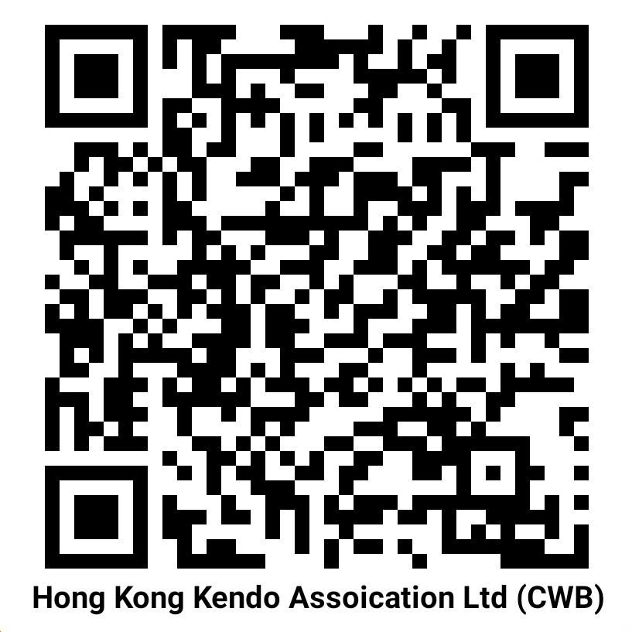

請注意: 考生必須於截止日期或之前提交報名表格、級/段位證明副本、入數證明。不過，考生必須用一張紙作答每一題、手寫、完成超過半頁並於考試當日提交。)

報考截止日期︰2023年8月16日(星期三)，下午5時或之前

中國香港劍道協會
2023年7月28日
Notes to applicants :
Registration will start from 1:30pm on 2nd September 2023 (Sat) at Jao Tsung-I Academy theatre.
Please fill in the application form with all the attachment required and email to HKKA
(email : hkka@hkolympic.org or by fax 2890 8052)
Kyu/Dan Application Form;
MUST attached with a copy of the present Dan certificate;
Applicants must attach 1Kyu certificate copy or get pass on that day. Applicants applying for 2Dan and above must attach their present dan certificates copy together with Dan application form or else your application will not be accepted.
HKKA will not be responsible for checking past record for applicants;
Administrative fee HKD200 will be charged by HKKA for checking the previous certificate record;
HKD200 will be charged for re-issuing certificate.( approximately 2 months period)
Deadline of Application: on or before 16th August, 2023 (Wednesday), 5:00pm;

Application Fees / Certificate Fees

1 Kyu HK$300.00 HK$100.00 Total : $ 400.00
1-Dan HK$800.00 HK$100.00 Total : $ 900.00
2-Dan HK$1000.00 HK$100.00 Total : $ 1,100.00
3-Dan HK$1,300.00 HK$100.00 Total : $ 1,400.00

Payment made by Alipay, Please refer the table below :
(1.5% shall be added on top of your examination fee as handling charge. Please scan the following barcode and email the proof to HKKA after payment.)

(For Alipay)Application Fees / Certificate Fees

1 Kyu HK$300.00 HK$100.00 Total : $ 406.00
1-Dan HK$800.00 HK$100.00 Total : $ 913.50
2-Dan HK$1000.00 HK$100.00 Total : $ 1,116.50
3-Dan HK$1,300.00 HK$100.00 Total : $ 1,421.00

•Certificate fee will be refund to unsuccessful examinee;
•Kyu/Dan application fees paid are non-refundable and non-transferable;
•Kyu/Dan examination fee will not be charged if HKKA receives the cancellation notice on
or before 23rd August, 2023 (Wed). Otherwise applicant needs to settle the full
payment of Kyu/Dan examination.
If candidates cannot perform sitting techniques, presenting medical certificate prove must attached and notify in advance;
Iaidou (sword) will provide for in examination if needed for FREE ;
Late and incomplete application forms will not be processed and will be returned to the applicant;
Dan application will not be processed if present Dan certificate not attached;
Application to the kyu/dan examination is restricted to members of the Hong Kong Kendo Association Limited and its affiliated dojo members or affiliated dojo members under FIK as approved by the President of HKKA;
All applications received will be subject to final approval by the President of HKKA;
Applicants will be disqualified from joining examination on the day if they fail to register on
2 pm on 2nd September 2023 (Sat);
Written test questions will be announced on HKKA website in due course, all answers for exam. Questions MUST use official paper which can be download from HKKA website. Answers hand in during registration on September 2nd
Examination fee MUST be settled on or before 16th August 2023.
Personal Data (privacy) Ordinance
The information in this form will be protected by the Personal Data (privacy) Ordinance
and classified as Confidential;
The information provided will be used for processing of membership registration and
other related purposes by this Association;
It may be disclosed to Heads of Department for investigation, registration and other
related purposes when required / demanded.
The Kendo Association of Hong Kong, China WILL NOT be held responsible for any injuries or loss of personal belongings of applicants during the examination day;

Payment Method:

Bank Transfer
Deposit / Transfer the fee to the Hong Kong Kendo Association Limited’s Hang Seng Bank account (Account No. 281-264200-001). Please send the remittance slip or advice together with the required documents to HKKA by email.

Pay by Cheque
A crossed cheque payable to "Hong Kong Kendo Association Limited” and send it by post or by hand to HKKA office.
Address: Room1029 Olympic House No.1 Stadium Path, So Kon Po, Causeway Bay, Hong Kong

Alipay
1.5% shall be added on top of your examination fee as handling charge. Please scan the following barcode and email the proof to HKKA after payment.
ALL Applicants MUST submit their application form, copy of Kyu/Dan certificate and payment records on or before 16th August 2023. BUT, ALL Applicants MUST write One question answer on ONE answer sheet in hand written, complete over half of the page and submit the answer sheets on the examination day (2nd September 2023).

Application Deadline: 16th August 2023 (Wed), 5:00pm
For and on behalf of The Kendo Association of Hong Kong, China Limited
28th July 2023

